COCKTAIL PLATTERS
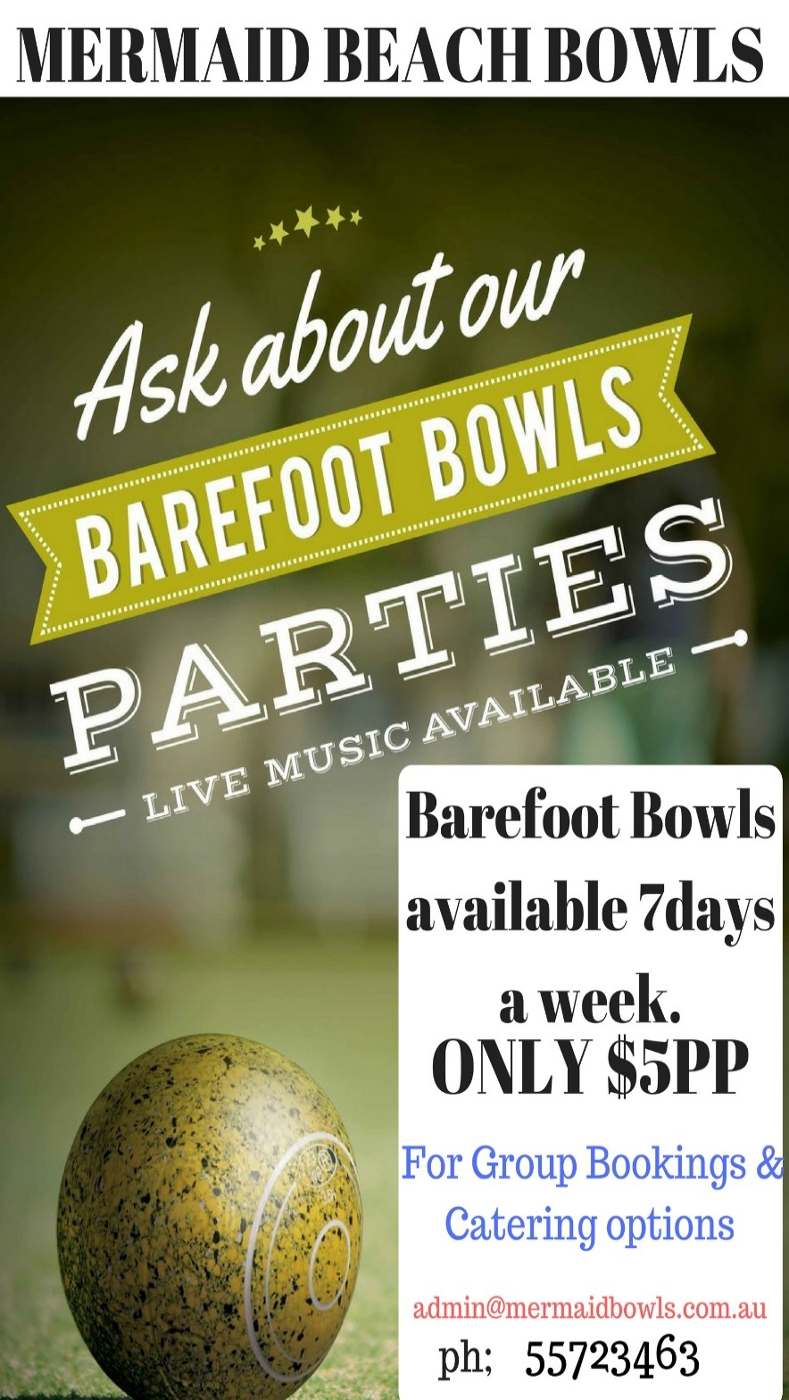
Platter A - $65
Party pies, sausage rolls, mini pastries, sauces, Approx 50 pieces.
Platter B - $65
Fish goujons, calamari, tempura prawn, sauces, Approx 50 pieces.
Platter C - $65
Samosas, spring rolls, dim sims, sauces, Approx 50 pieces. $65 (VG)
Platter D - $95
15 Beef slider, 15 chicken sliders. (V & VG options available)
Platter E - $65
Mixed sushi or vegetarian sushi, Approx 36 pieces. (All seafood sushi, Approx 40 pieces $85)
Platter F - $49
Assorted sandwiches, Approx 40 pieces. (V & VG options available)
Platter G - $49
Crudites, trio of dips, cheese and crackers. (V & VG options available)
Platter H - $85
Gluten friendly platter with a selection of hot & cold gluten friendly delights.
Platter I - $85
Prawn twisters, salt & pepper calamari strips, crumbed crab claws, sauces, Approx 50 pieces.
Platter J - $95
Smoked salmon hors du verre, smashed avocado corn bites, Persian fetta melbas, Approx 60 pieces.
Platter K - $75
45 Chicken skewers, a choice of Satay, sweet chilli or honey soy.
COCKTAIL PLATTERS
Platter L - $95
Antipasto platter, ham, salami, sun-dried tomatoes, Sicilian olives, bocconcini, grissini, cheddar, smoked chicken, roast capsicum.
Platter M - $49
Fresh seasonal fruit with clotted cream & yoghurt. (V & VG options available).
Platter N - $75
Camembert, vintage chedder, Persian fetta, blue cheese, dried fruits, quince jam, assorted crackers.
Platter O - $75
3kg Chicken wings, choice of Buffalo, sweet soy & lime, southern fried or smokey Bbq.
Platter P - $45each
Pizza slabs, assorted varieties available.
Platter Q - $85
30 mini quesadillas with baby hash browns & sauces.
Platter R - $75
Garlic chicken balls, jalepeno poppers, spinach & ricotta rolls, sauces.
Platter S - $75
Thai fish cakes, battered pork pieces, prawn gyoza, sauces.
Platter T - $95
Arancicni ragu, arancini porcini & truffle Approx 70 pieces.
Platter U - $65
Nuggets , cheerios, chips, Approx 40 pieces + chips.

Platter V - $195
Mermaid Grazing platter, smoked salmon side, crispy capers, dill accented cheese, water crackers, cabana, chorizo, hot salami, diced cheddar, camembert, assorted crackers.

